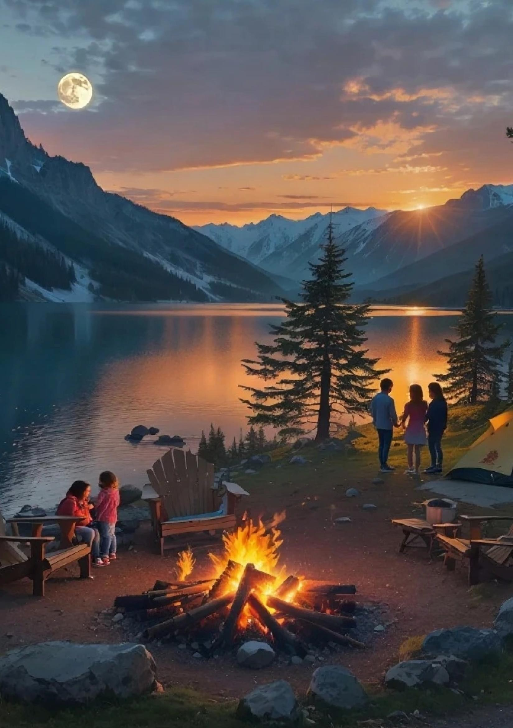

1

Camping with your family

10 Essential Tips for a Safe and Enjoyable Family Camping Trip (Kids + Dogs)
Planning a camping trip with children and pets can be incredibly rewarding — but it does require a little extra preparation. Use these tips to keep everyone safe, comfortable, and happy on your next outdoor adventure.

1. Choose a Family-Friendly Campsite
Select a campground that offers family-oriented amenities like clean restrooms, running water, and pet-friendly areas. Look for flat terrain, clear boundaries, and safe surroundings for children to explore.

2. Pack a Complete First Aid Kit
Carry essentials such as bandages, antiseptic wipes, insect repellent, sunscreen, and any personal medications for both kids and pets. Review basic first-aid steps before your trip so you’re prepared for minor mishaps.

3. Plan Easy Meals and Smart Snacks
Bring plenty of kid-approved snacks and simple meal options. Store all food securely to avoid attracting wildlife and to keep your campsite clean and safe.

4. Practice Safe Campfire Habits
Keep your campfire small, controlled, and always supervised. Teach children fire-safety rules and set a clear “no-go” zone around the flames.

5. Keep Pets Secure
Use a leash, harness, or tether when your dog is outside the tent. This prevents wandering, protects wildlife, and keeps your pet safe from unexpected dangers.

6. Stay Hydrated
Make sure everyone — including your dog — drinks plenty of water throughout the day. A portable water filter is a great backup for longer trips.

7. Dress for Changing Weather
Pack layers, waterproof jackets, and sturdy footwear so kids stay warm, dry, and comfortable no matter what the forecast brings.

8. Set Safe Exploration Boundaries
Give children and pets clear limits on where they can roam. Use easy-to-spot landmarks as visual markers and check in regularly.

9. Teach Wildlife Awareness
Show kids how to admire wildlife from a distance. Discuss what to do if they encounter animals and emphasize respecting nature.

10. Practice Leave No Trace
Encourage children to care for the environment by cleaning up after themselves and the family dog. Leave nature exactly as you found it — or better.

With thoughtful planning and clear safety habits, your family camping adventure can be both memorable and worry-free. Get outdoors, explore together, and create moments you’ll treasure for years.

Things you should be mindful of
Be Prepared: Key Essentials for a Safe and Enjoyable Camping Experience
Camping is a rewarding way to reconnect with nature, but preparation is essential for a safe and memorable trip. Before you head out, always check the weather forecast—conditions can shift quickly and may affect your plans. Pack appropriate gear, including a durable tent, a warm sleeping bag, and layered clothing suited to the climate.
Be aware of local wildlife and store all food securely to avoid attracting animals to your campsite. Use reliable navigation tools such as a map, compass, or GPS that works offline, and take time to familiarize yourself with trails and campsite locations.
Carry a well-stocked first-aid kit and know how to handle basic medical situations. Finally, practice Leave No Trace principles to help preserve the natural environment for future campers. By preparing properly and respecting nature, you’ll set yourself up for a safe, enjoyable, and unforgettable outdoor adventure.
3

Tech item & games to consider

Tech & Fun for the Outdoors: How to Enhance Your Camping Adventure
When heading out on a camping trip, the goal is simple: enjoy nature, unwind, and create unforgettable memories. While camping is often about switching off from the busy world, bringing the right tech and entertainment can elevate the entire experience—without taking away from the magic of the outdoors. With a few smart gadgets and some fun, lightweight games, you’ll be prepared, comfortable, and entertained from sunrise to starlight.

Smart Tech to Bring Along

Portable Solar Charger
Power can be limited in the wild, so a portable solar charger is a fantastic tool to keep your essential devices powered. It allows you to recharge during the day using nothing but sunlight—perfect for phones, headlamps, GPS devices, and cameras.

Reliable GPS or Offline Navigation App
Cell service is never guaranteed once you step into remote areas. Bring a dependable GPS unit or download offline maps before you leave. Knowing your route and landmarks gives you confidence on every trail and ensures you can explore without worry.

Durable Power Bank
A rugged power bank is a must for any modern camper. Choose one with a larger capacity so you can recharge multiple devices over the course of your trip. Look for shockproof or water-resistant options for added reliability.

Weather-Resistant Bluetooth Speaker
Whether you're relaxing by the campfire or cooking dinner under the trees, a small Bluetooth speaker can provide the perfect soundtrack. Just keep volume moderate—enjoy music without disturbing wildlife or neighbouring campers.

High-Lumen LED Flashlight or Headlamp
Nighttime in the wilderness hits differently, and quality lighting is essential. A bright LED flashlight or headlamp will help you navigate your campsite, read in your tent, or take late-night walks with confidence. Choose a rechargeable one to pair with your solar charger.

Rugged Action Camera
Capture the best moments of your adventure—from scenic trails to fun campfire moments. An action cam is built to handle rough conditions and gives you lasting memories you can relive and share.

Water-Resistant E-Reader
For quiet moments, an e-reader offers entertainment without extra weight. With a long battery life, it’s perfect for winding down in your hammock or tent at night.

Camp-Friendly Games and Activities
Not every moment outdoors needs a screen. The best camping trips mix nature with shared laughter and creativity. Bring a few simple, lightweight games for evenings around the fire or lazy afternoons.

Card Games
A deck of playing cards or a game like Uno offers endless possibilities for groups of all ages. They take up almost no space and are perfect for winding down after a day of adventure.

Frisbee
Great for open spaces and daytime energy, a frisbee gets everyone moving and laughing. It’s ideal for families, groups, or even playing with the dog.

Campfire Classics: Charades or Storytelling
Simple games that require nothing but imagination are often the most memorable. Charades brings plenty of laughs, while storytelling—especially spooky tales by the fire—creates the moods and moments people remember forever.

Nature Scavenger Hunt
Engage kids and adults alike by letting them explore the environment with purpose. Create a list of natural items to find—like pinecones, feathers, certain leaves, or animal tracks—to make exploration interactive and educational.

Word Games: 20 Questions or I Spy
Perfect for bedtime or quiet evenings, these classic games keep everyone entertained without needing supplies. They’re especially helpful for younger campers or winding down before sleep.

Make Memories, Stay Prepared, and Have Fun
By combining a few handy tech tools with easy entertainment, your camping trip becomes more comfortable, more engaging, and more memorable. The goal isn’t to bring more—it’s to bring what adds value. Prepare thoughtfully, be present in the moment, and let both nature and creativity shape your adventure. With the right balance, your nights under the stars will be filled with laughter, comfort, and unforgettable experiences.

Check List to Take
[] Tent and Tent Accessories: Ensure you have a sturdy tent, stakes, guy lines, and a footprint or tarp for ground protection.
[] Sleeping Bag and Sleeping Pad: Pack a sleeping bag suitable for the weather and a sleeping pad for added comfort and insulation.
[] Cooking Supplies: Bring a portable stove, fuel, lighter or matches, cooking utensils, pots, and biodegradable soap for cleaning.
[] Food and Water: Pack non-perishable food items, snacks, and a sufficient water supply or a filtration system for purifying natural water sources.
[] Clothing and Footwear: Dress in layers for varying temperatures, and include sturdy hiking boots or shoes, extra socks, and rain gear.
[] First Aid Kit: Include bandages, antiseptic wipes, pain relievers, insect repellent, and any personal medications you may need.
[] Navigation and Safety Tools: Carry a map, compass, GPS device, flashlight or headlamp with extra batteries, and a multi-tool or knife.
[] Personal Items and Toiletries: Bring biodegradable toiletries, a towel, sunscreen, lip balm, and a trash bag for packing out waste.
Adjust the list based on your specific needs and the duration of your camping trip. Safe travels and enjoy the great outdoors!

4x4 items to include if going bush
When setting out on a 4x4 adventure in the bush, it's crucial to be well-prepared with the right equipment and supplies to ensure both safety and convenience. Start with a comprehensive first aid kit, which is essential for handling any minor injuries that may occur. Make sure to pack extra water and nonperishable food items, as well as a portable water purifier in case of extended stays. A reliable GPS device and detailed maps can help you navigate unfamiliar terrain, while a satellite phone or personal locator beacon is invaluable for emergency communication in remote areas. Recovery gear, such as a winch, snatch straps, and a shovel, is vital for getting out of tricky situations, along with a tire repair kit and air compressor to manage any punctures or pressure issues. Additionally, packing a set of basic tools and spare parts can help you tackle any mechanical problems on the go. Lastly, ensure your vehicle is in top condition before departure, and consider traveling with a buddy or in a convoy for added safety.

